With age.

Took me pretty long to run all the glmer models again at home, took even longer with an extra variable. After adding age as an extra variable, all hind models have the lowest AIC, and are also mostly significant and in the right direction.

**Summary**

**Yellow = insignificant**

|  | **glmer** | **glmmTMB** | **glmer**  **No Birthwt** | **glmmTMB**  **No Birthwt** |
| --- | --- | --- | --- | --- |
| **Hinds** | **-0.484 (p=1.06e-14)** | **-0.920 (p=1.06e-13)** | **-0.173 (p=0.428)** | **-0.223 (p=0.0273)** |
| **Adults** | **0.0102 (p=7.10e-13)** | **-0.227 (p=0.199)** | **0.155 (p<2e-16)** | **-0.231 (p=0.0166)** |
| **Total** | **-0.114 (p=0.593)** | **-0.584 (p=0.094)** | **0.104 (p<2e-16)** | **-0.1997 (p=0.0203)** |
| **LU_Total** | **0.0535 (p=0.933)** | **-0.223 (p=0.0273)** | **0.191 (p<2e-16)** | **-0.504 (p=0.316)** |

**AIC**

|  | **glmer** | **glmmTMB** | **glmer**  **No Birthwt** | **glmmTMB**  **No Birthwt** |
| --- | --- | --- | --- | --- |
| **Hinds** | **510.6** | **491.4** | **1526.4** | **1466.8** |
| **Adults** | **523.4** | **502.4** | **1532.9** | **1470.0** |
| **Total** | **520.0** | **497.9** | **1532.6** | **1470.7** |
| **LU_Total** | **524.0** | **503.0** | **1531.0** | **1471.7** |

**Scaled (Yellow = insignificant)**

|  | **glmer** | **glmmTMB** | **glmer**  **No Birthwt** | **glmmTMB**  **No Birthwt** |
| --- | --- | --- | --- | --- |
| **Hinds** | **-11.4 (p=0.00011)** | **-25.16 (p<2e-16)** | **-4.85 (p<2e-16)** | **-5.18 (p=0.0274)** |
| **Adults** | **-4.01 (p=0.503)** | **-6.97 (p=0.215)** | **-3.11 (p=0.281)** | **-7.09 (p=0.0168)** |
| **Total** | **-6.122 (p=0.0796)** | **-13.82 (p=0.00074)** | **-2.31 (p=0.410)** | **-6.84 (p=0.0204)** |
| **LU_Total** | **-2.195 (p=0.552)** | **-22.51 (p=0.0944)** | **0.796 (p=0.913)** | **-6.08 (p=0.317)** |

**Scaled AIC**

|  | **glmer** | **glmmTMB** | **glmer**  **No Birthwt** | **glmmTMB**  **No Birthwt** |
| --- | --- | --- | --- | --- |
| **Hinds** | **511.8** | **494.2** | **1520.3** | **1466.8** |
| **Adults** | **520.7** | **502.4** | **1528.7** | **1470.0** |
| **Total** | **522.4** | **501.6** | **1529.3** | **1470.7** |
| **LU_Total** | **520.2** | **503.0** | **1530.5** | **1471.7** |

**glmmTMB**

**Hinds**

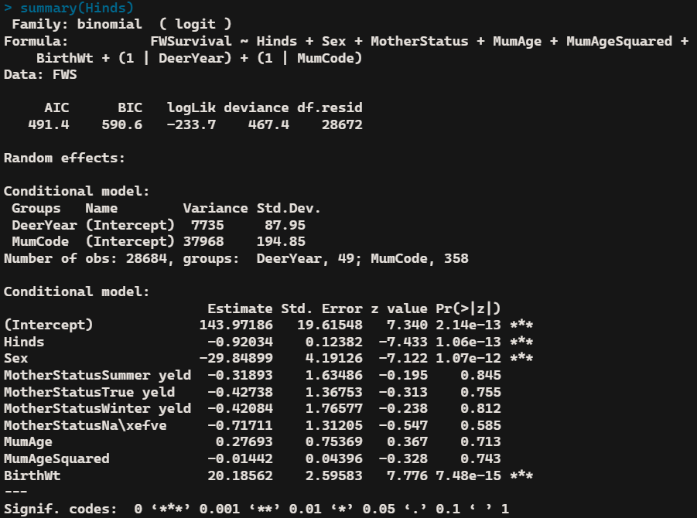

**Adults**

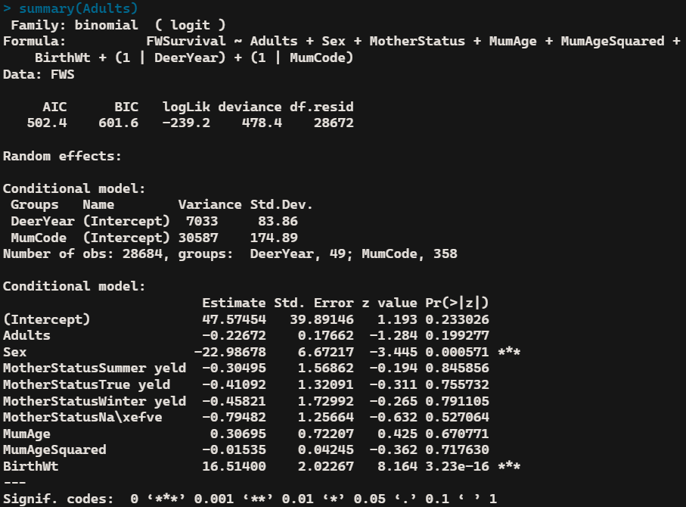

**Total**

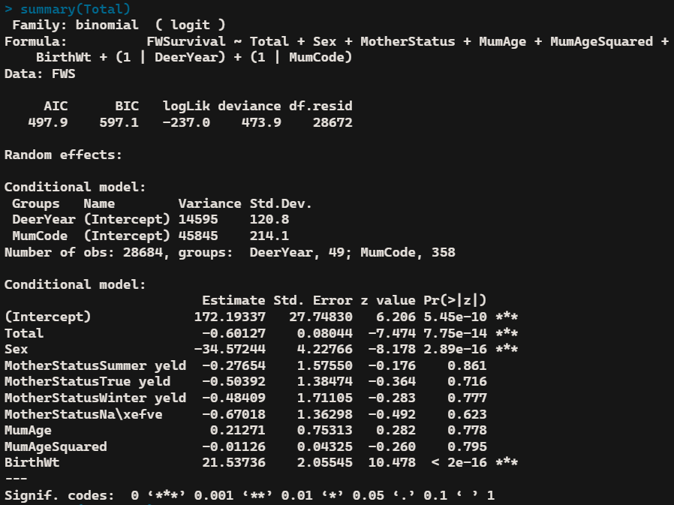

**Livestock Units**

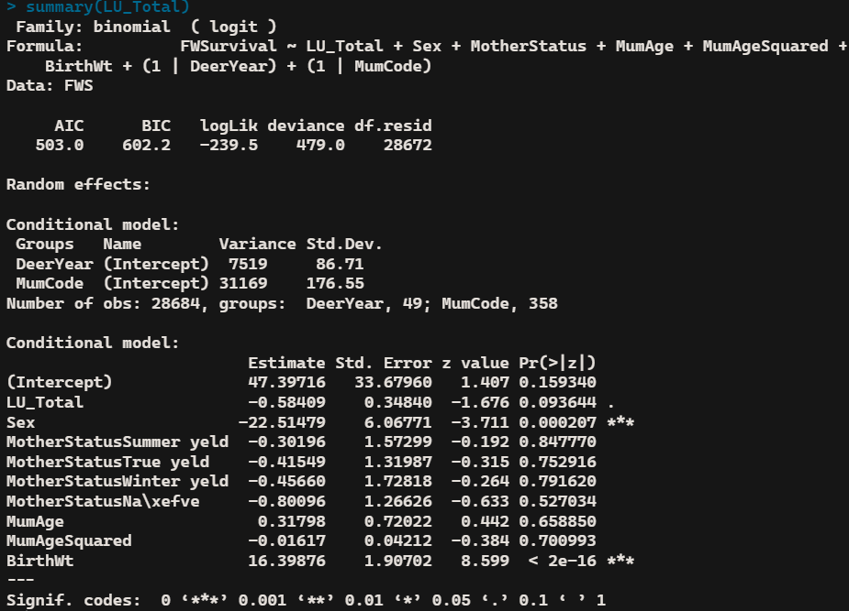

**glmmTMB**

**Hinds w/o birth weight**

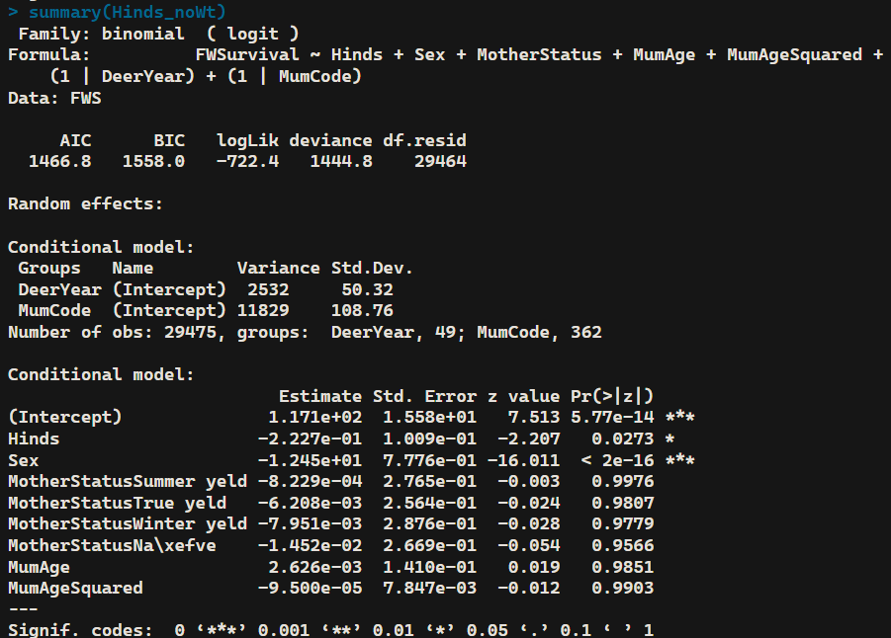

**Adults w/o birth weight**

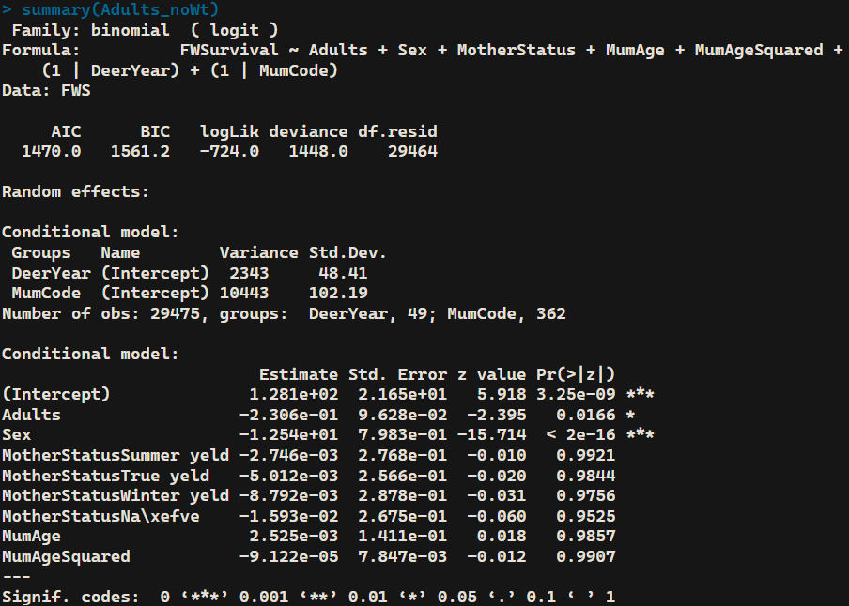

**Total w/o birth weight**

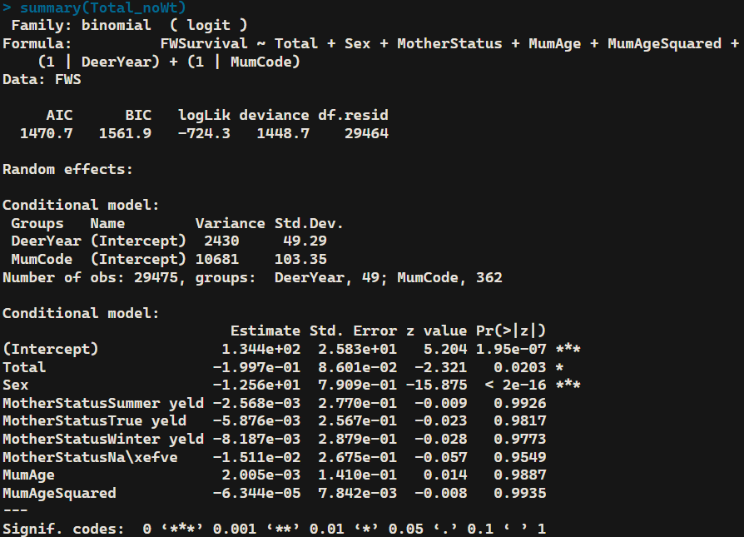

**Livestock Units w/o birth weight**

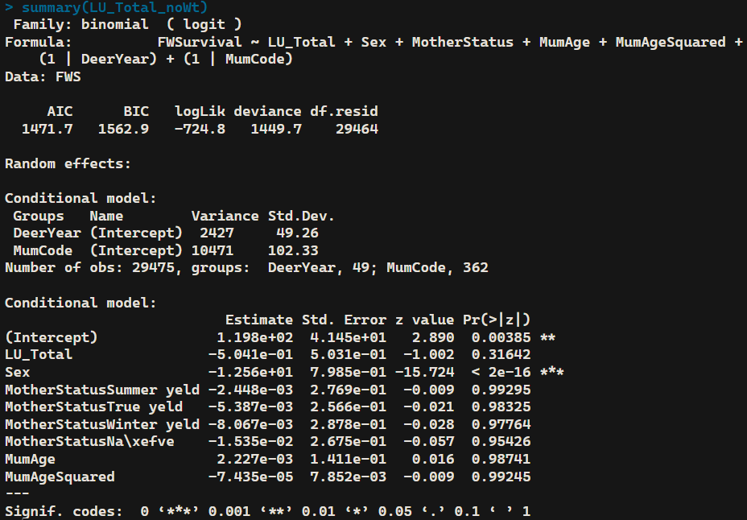

**glmmTMB**

**Scaled Hinds**

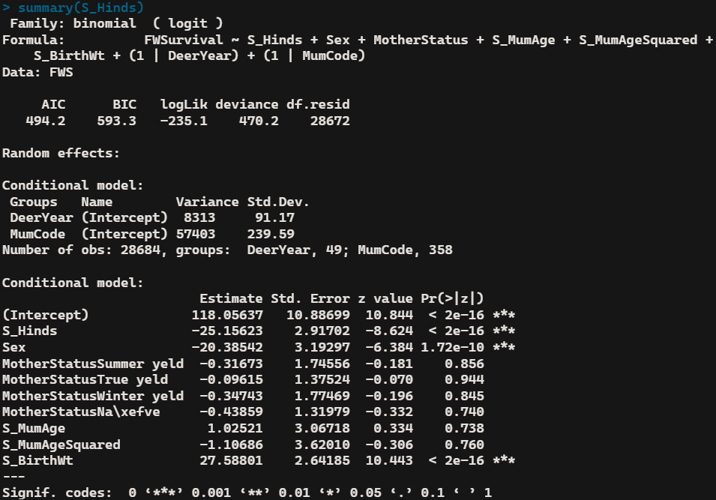

**Scaled Adults**

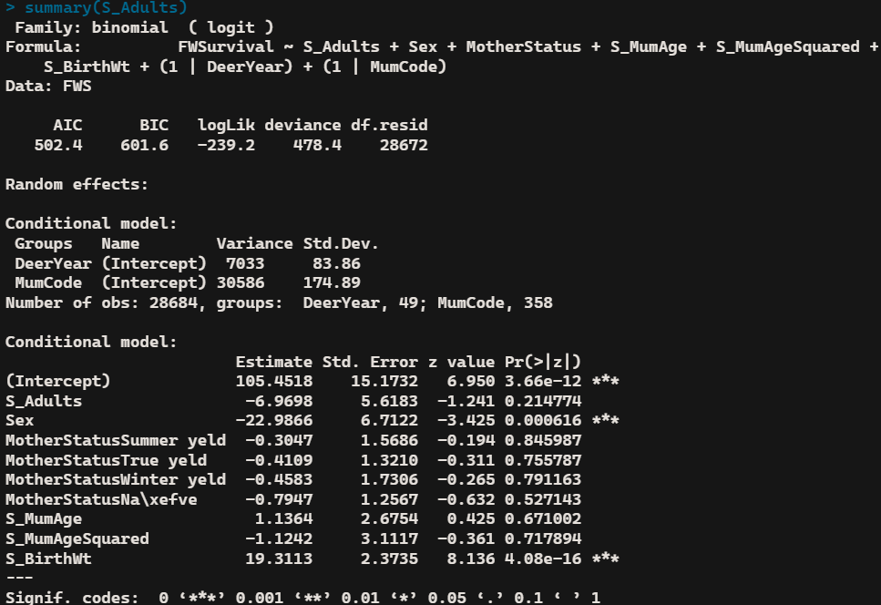

**Scaled Total**

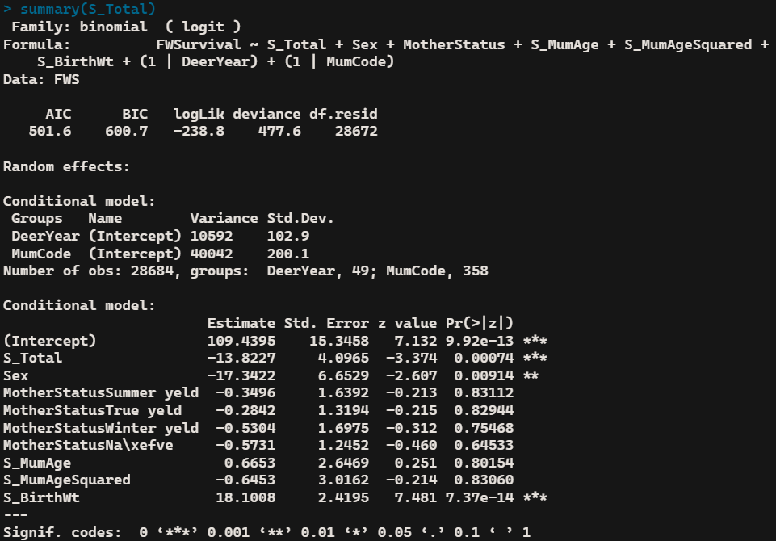

**Scaled Livestock Units**

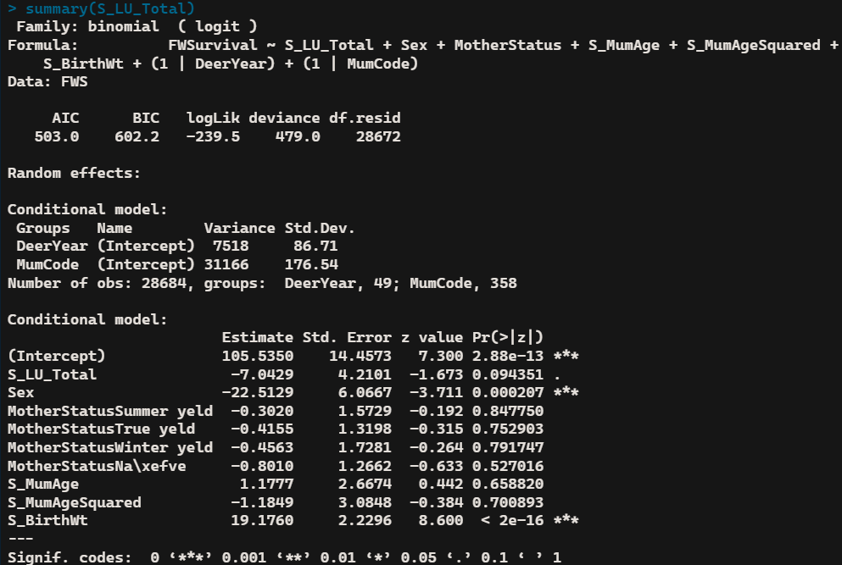

**glmmTMB**

**Scaled Hinds w/o birth weight**

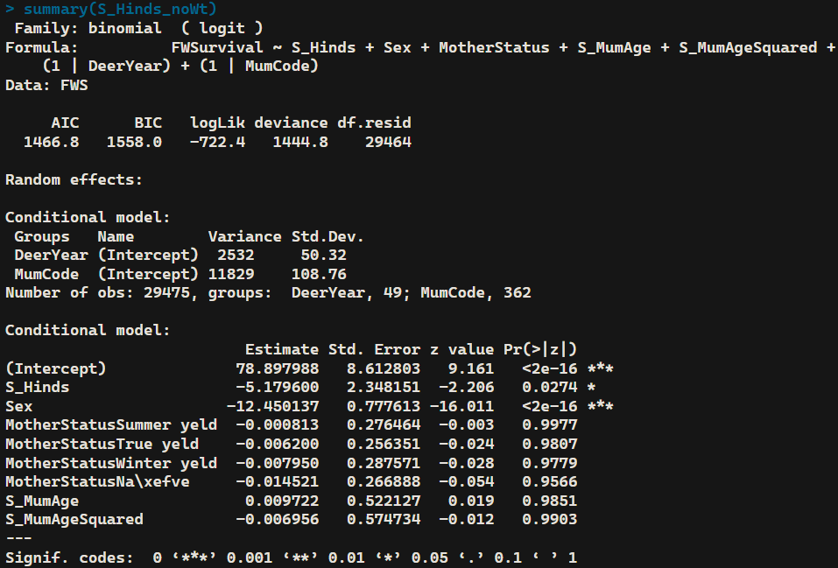

**Scaled Adults w/o birth weight**

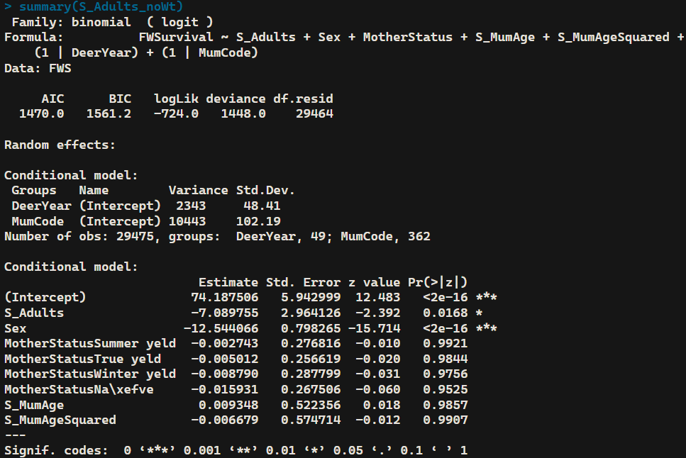

**Scaled Total w/o birth weight**

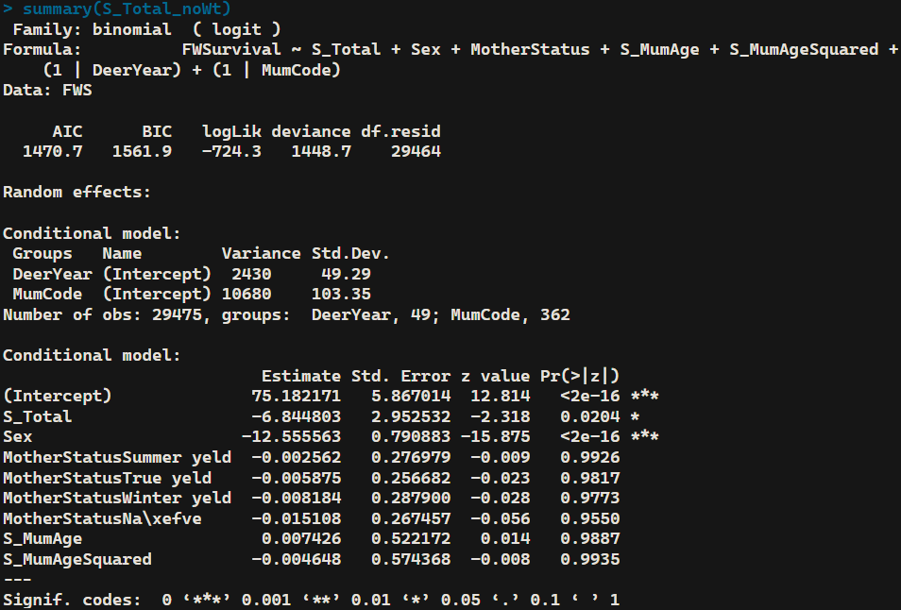

**Scaled Livestock Units w/o birth weight**

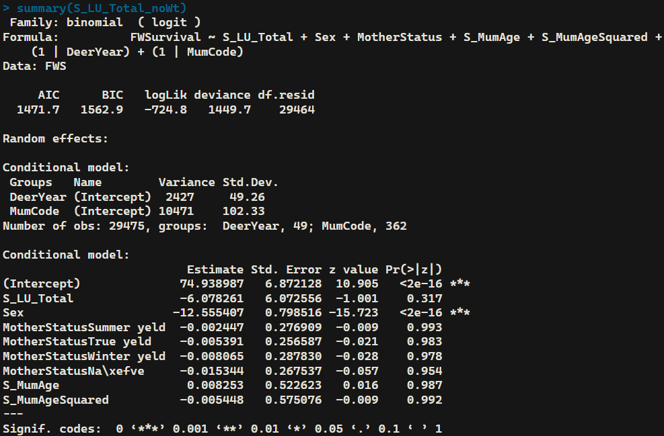

**glmer**

**Hinds**

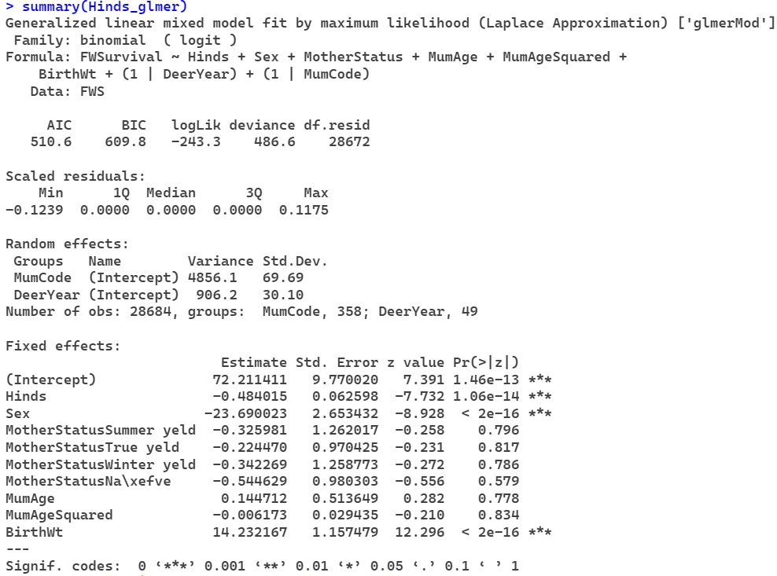

**Adults**

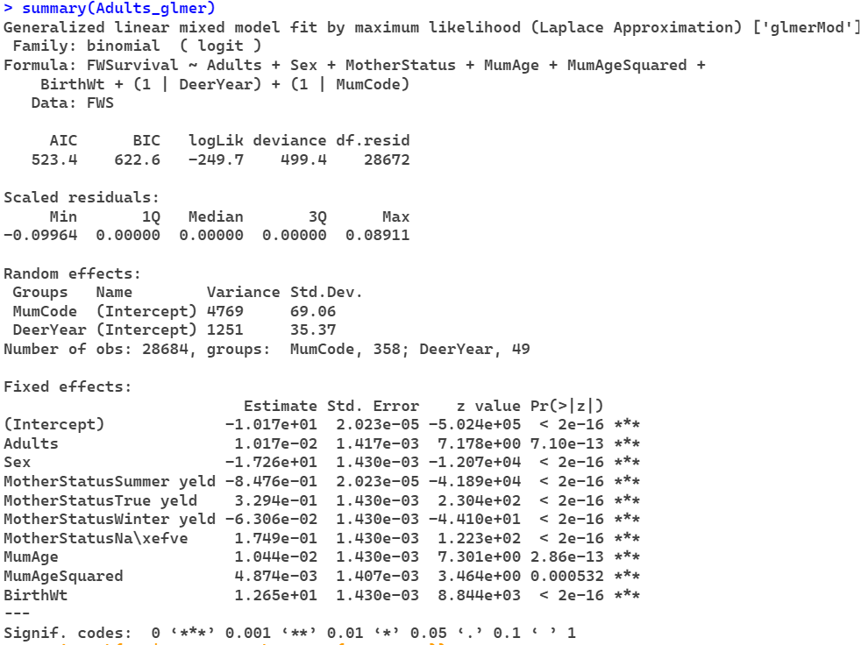

**Total**

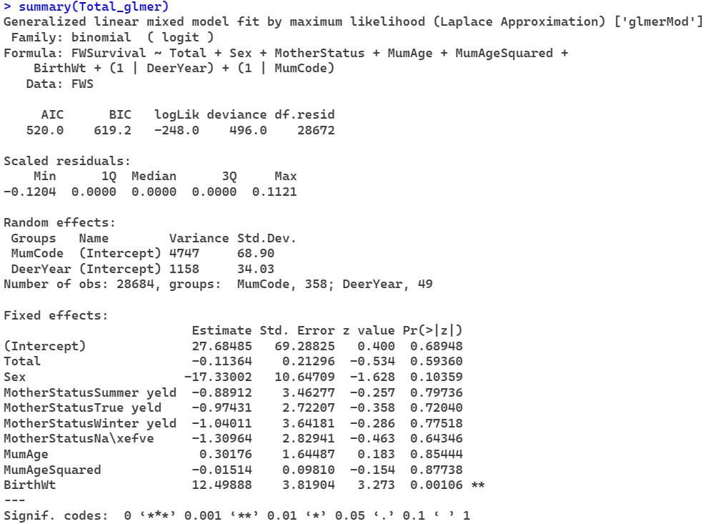

**Livestock Units**

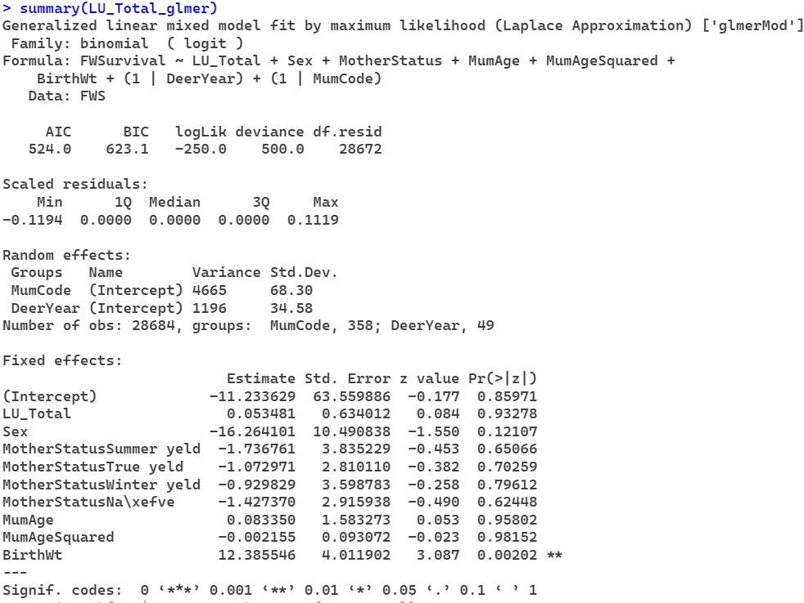

**glmer**

**Hinds w/o birth weight**

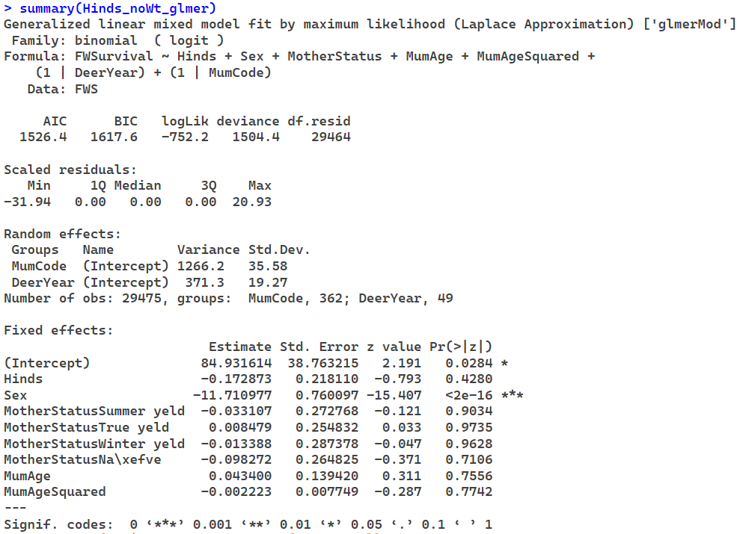

**Adults w/o birth weight**

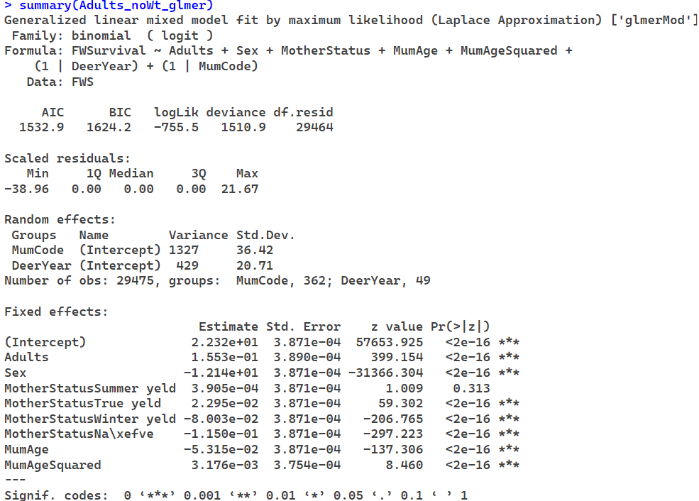

**Total w/o birth weight**

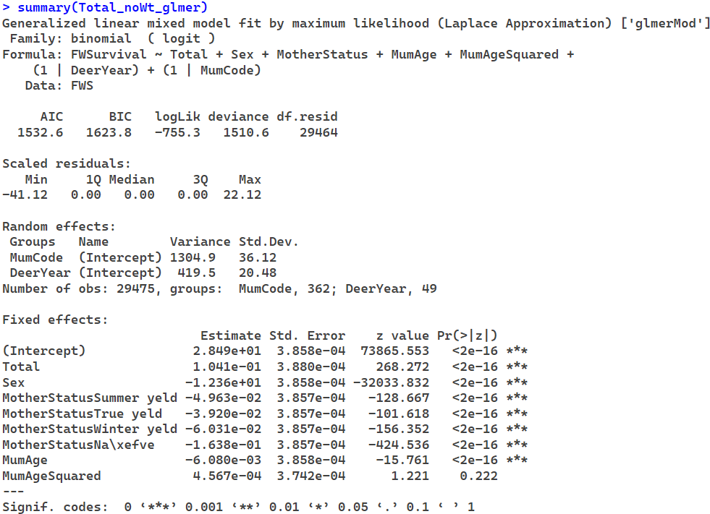

**Livestock Units w/o birth weight**

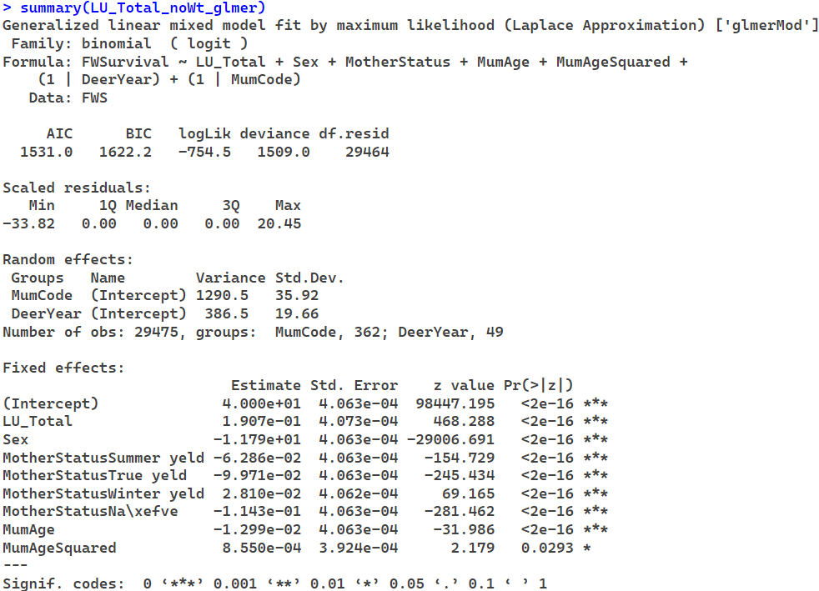

**glmer**

**Scaled Hinds**

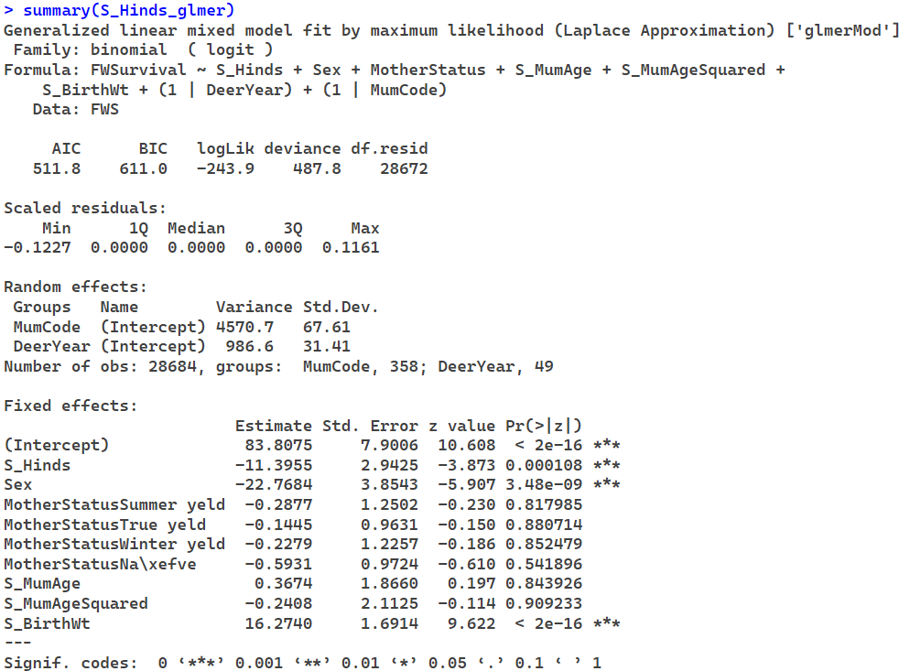

**Scaled Adults**

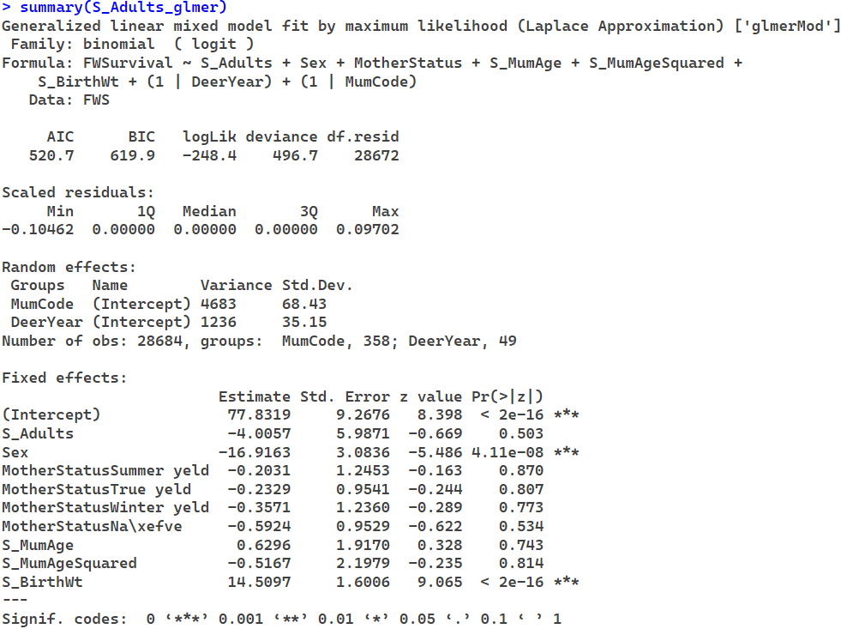

**Scaled Total**

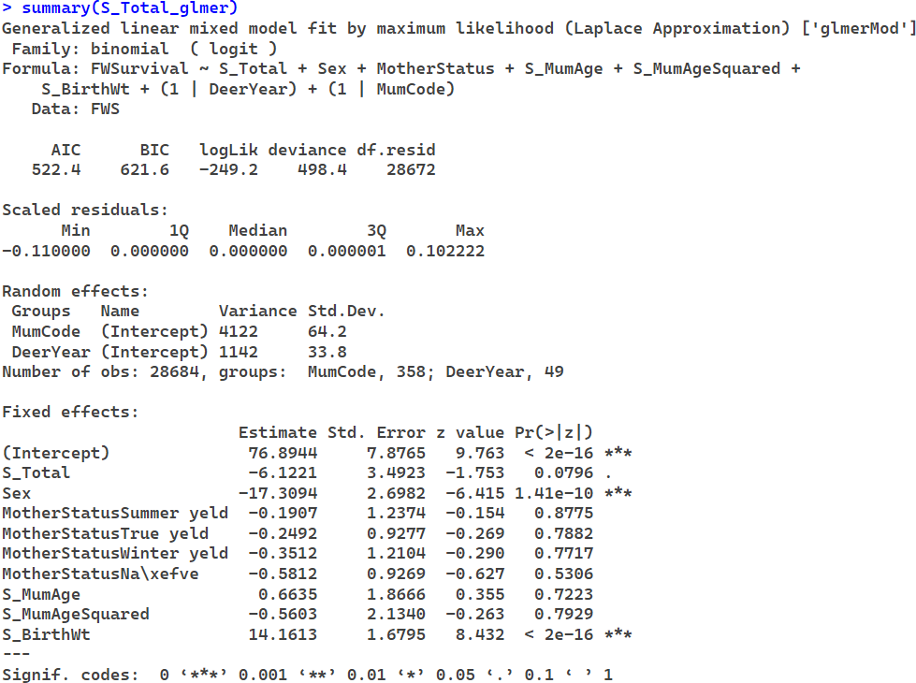

**Scaled Livestock Units**

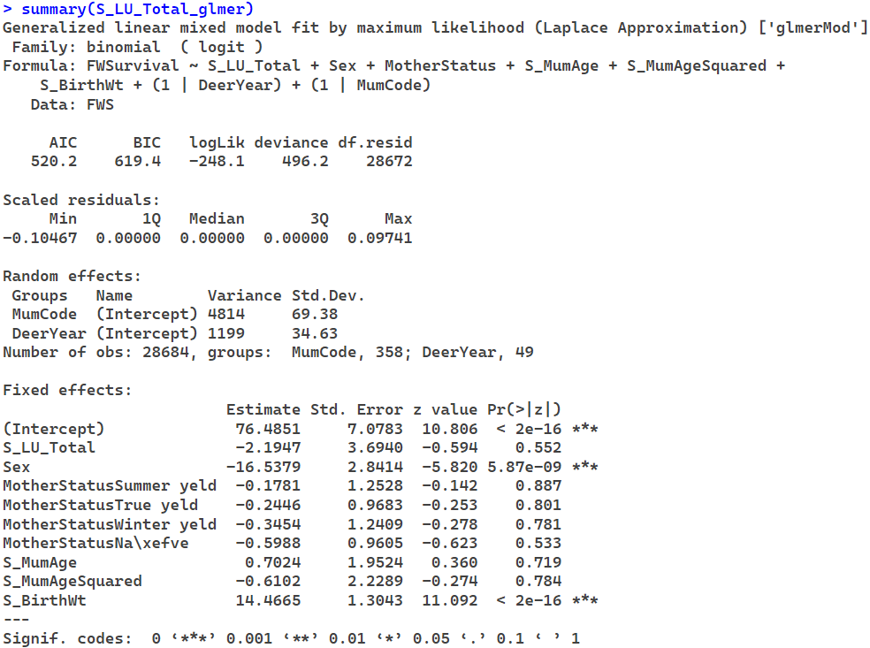

**glmer**

**Scaled Hinds w/o birth weight**

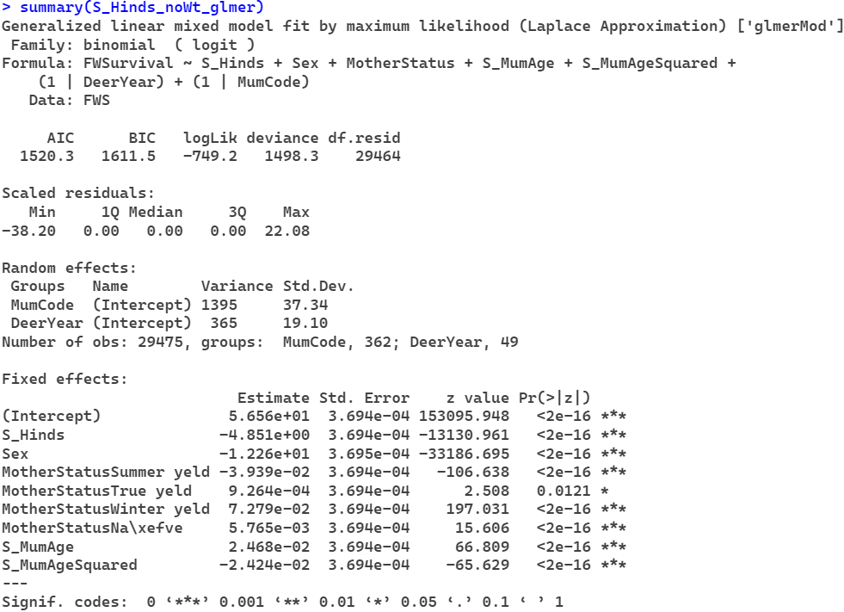

**Scaled Adults w/o birth weight**

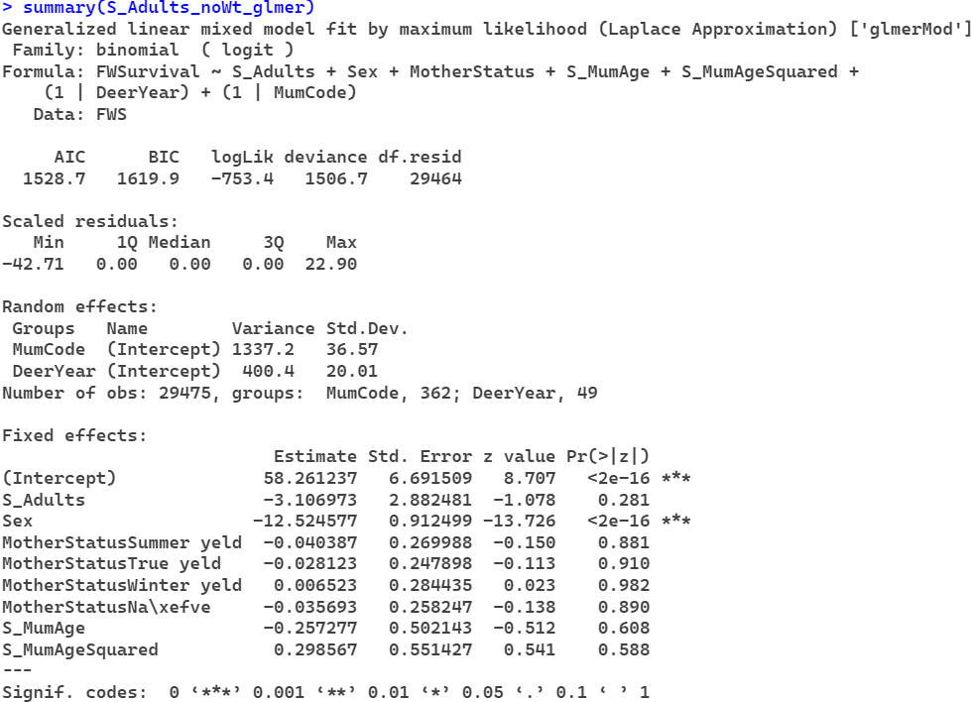

**Scaled Total w/o birth weight**

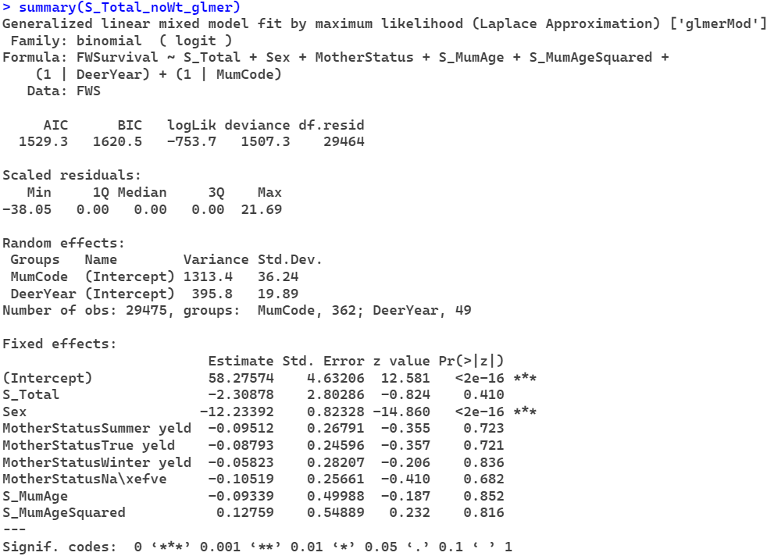

**Scaled Livestock Units w/o birth weight**

